Welcome to 2nd Grade

I would like to take this opportunity to welcome you and your child to West Chatham Elementary School. I hope this handbook will contain useful information and answers to most of your questions. If you have any questions, please be sure to get in touch with me.
Who is Mrs. Taylor?
I am Jessica Taylor. I have lived in Georgia since the summer of 2013. My dad was in the military so I moved around a lot, but I call Mississippi home. I graduated from the University of Mississippi (Ole Miss) with a Bachelor Degree in Elementary Education. I have taught since August of 2010. I learn something new every year to better my teaching and I love it! I have taught both 2nd and 1st grade. I have a 8-year-old boy and 7-year-old girl. Their names are Toby and Skyla. I am sure you will be hearing their names a lot throughout the year.

Communication
It is very important for your child’s school year to be fun and successful. You can help that happen by checking your child’s daily folder (face to face only) , by communicating with me and reading the notes that are sent home (will be sent in It’s Learning and Class Tag while virtually). There will be a newsletter on Mondays in your child’ folder (this will be posted on It’s Learning and Class Tag. Please take the time to read it and any other, so you can be an informed parent. I do ask that you sign the newsletter, so that I know you have read it (face to face only). The newsletter will have important information for the week, such as important dates, what we are learning for the week, spelling words, and trick words. The best way to contact me is through email or the Behavior Log (this will be posted through Class Tag while virtually) that is placed in your child’s folder each week. On this sheet, I will write notes and notify you about homework and behavior (when we have face to face learning). You can call me here at the school: 912-748-3600. While we are on virtual my number is 912-483-9384. However, I don’t answer while I’m teaching, so please leave a message and I will check it as soon as I get a chance. My website is http://jtaylorclass.weebly.com/. My website has a lot of documents sent out and resources that go along with the standards. My email address is: Jessica.taylor@sccpss.com

What will the day look like Virtually?
Virtual school will be very similar to face to face school. I will have small and large group zoom meetings. I will teach in the zoom meetings and students will have a chance to show their work in the It’s Learning platform. Please let your child do their own work. I will not know he or she is struggling if someone else is doing his or her work. Someone can help them with assistance, but please do not give them the answer.
Each day students will receive direct instruction to support literacy, mathematics, science, social science, and specials/connections adhering to the student’s provided schedule. While teachers will provide direct instruction based on the student’s schedule, it should be clearly noted that the time indicated in the schedule is inclusive of direct instruction, small group instruction, independent tasks, and other activities that demonstrate a student’s mastery of the standards. Teachers will be available online during the entire class period as indicated in the schedule to provide additional support, conduct small groups, and answer questions as students work to complete their lessons.
Stay tuned for schedule!
Wednesdays
Wednesdays we will not meet as a whole class, but some students will meet as a small group. This day is for students to finish assignments and submit as needed, instructional focus for remediation and enrichment; participate in personalized support to attain mastery of the content and skills of the course, SCCPSS lunch distribution, etc.
I cannot stress to you the importance of your child being present at school every day. Documentation shows that students who have great attendance will have great accomplishments and be more successful throughout their educational years. With that being said, please make sure that your child is at school and that they arrive on time.

Uniforms
Students do not have to wear uniforms but they do need to be dressed appropriately for a school setting. If they would not wear it at school, then they should not wear it on zoom.

Absences
Virtual Only
Virtual attendance
Student Attendance: Participation
Attendance will be defined by a student’s participation. Students will be considered in attendance when they are participating in active instruction and/or educational services. This will apply to in-person, virtual, remote, or hybrid models. Examples include time spent working in the online platform, log-in activity, attendance during live instruction, submission of student assignments, and student/teacher interactions.
Definition of Participation: Actively participating includes any of the following:
✓ Login and work in class/courses every day
✓ Participate in online class every day
✓ Complete and submit assignments or tasks by due dates
✓ Participate in group activities
✓Direct daily interaction with a certified instructional staff member (online, email, or phone)
When there is No Internet Connection:
When working from a printed packet, or refueling station, students must engage in the learning activities assigned through this method. Teachers will be in contact with students to monitor activity, provide assistance, and offer instructional support. Students will be considered in attendance based on participation through teacher engagement and submission of assignments.
Absence:
If a student is going to be absent, a parent or guardian must alert the student’s teacher by email or phone. After a student is enrolled and he/she has not successfully been in contact with his/her teacher for more than 48 hours without an approved absence notification, the teacher will contact the student’s parent/guardian and document the attempt(s) as well as the outcome (i.e. made contact or unable to reach the parent/guardian). Teachers should make reasonable attempts to make contact after 24 hours and no later than 48 hours. Attempts to contact the student and parent/guardian should include email as well as a phone call. After the 3rd unsuccessful attempt, a referral will be made to the School Social Worker. The School Social Worker will then follow the district process for making contact with the student and family.
Absence policy:
- Only 5 handwritten notes may be accepted for the school year
- All other notes must be doctored excuses
- All excuses must be turned in within three days of your child returning to school or the day or days will be counted as unexcused absences
- After 5 unexcused absences your child is truant

Lunch/ Breakfast Money

SCCPSS Meal Service Plan (virtual only)
Point of Sale Service to be offered. Monitor sccpss.com for schedule updates!
THE MEALS ON THE BUS GO ROUND AND ROUND! Throughout the virtual learning model, school lunch will be available to SCCPSS students and will be provided at designated bus stops at designated times. The District is planning a point of sale process that will allow students to purchase lunch just as if they were in school!
- A student ID will be required.
- There will be no cash accepted at bus stops (payment must be completed in advance online).
- • School breakfast will continue to be offered at no cost.
- • Meal Service schedules will be posted/updated at sccpss.com
Prior year meal status will remain through September 30, 2020, so make sure to fill out your free/reduced meal application today! Parents and guardians will have until September 30 to complete the application process for free and reduced meals. Remember, SCCPSS families who receive free/reduced lunch must reapply each year to maintain their recipient status.
MEAL APPLICATIONS:
Paper applications are available at the Application Center located at 3609 Hopkins Street, Savannah, GA, 31404. Please make an appointment by calling 912-395-1066. Both online and paper applications are available in English and Spanish. There is also a meal application drop box located at the site for after hours delivery. The district strongly encourages parents to apply online by going to myschoolapps.com. The link is available on the district’s School Nutrition page at sccpss.com or by clicking the following link - simply visit: https://www.myschoolapps.com
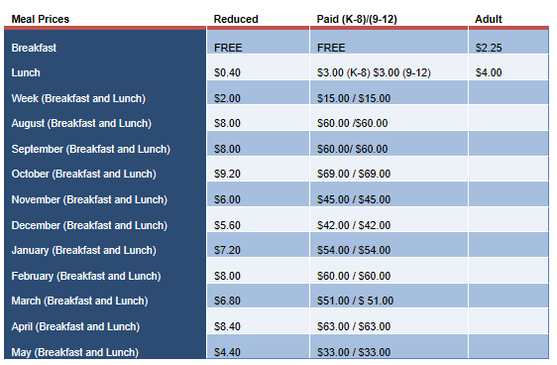
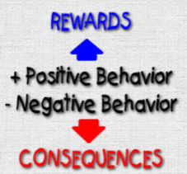Behavior Management
I will communicate through Class Tag if your child is not following the rules. I will talk to your child after class about the behavior. If the behavior continues to happen, then we will need to schedule a conference. Your child is here to learn so I take misbehaving very seriously because it takes away from others learning. I need your help with this, so please address your child about his or her behavior.
The class gets a chance to be “caught doing well” as a class. I will put marbles in a jar to earn class awards (These will be used for face to face). At the end of the week if your child has been on green all week they will get to participate in a fun activity on Friday. We will do stickers eagles when we return to class. At the end of the day, students will get shout outs for doing something great that day!
Please refer to the discipline policy separate sheet for more details. There will be a different discipline plan for face to face and virtual.

Again, welcome to West Chatham Elementary! I truly look forward to working with you and your child. As a team, we will see your child grow and be successful this year. Our goal is for them to learn all that they can, be prepared for Second Grade, and to truly have a love of learning!
Thanks for your support, and all you do to make this a successful year for your child.
Sincerely,
Jessica Taylor

Thank you for reviewing the handbook. Please fill out the google form stating that you have read the contents of the 2nd grade Handbook. https://docs.google.com/forms/d/e/1FAIpQLSd9ULvaodpS9ndX91_X-mbWWJgl7UTlaqulURYp5gtAQ3hUFg/viewform?usp=sf_link

Please keep scrolling for face to face part of the handbook and a checklist that might help for at home learning.

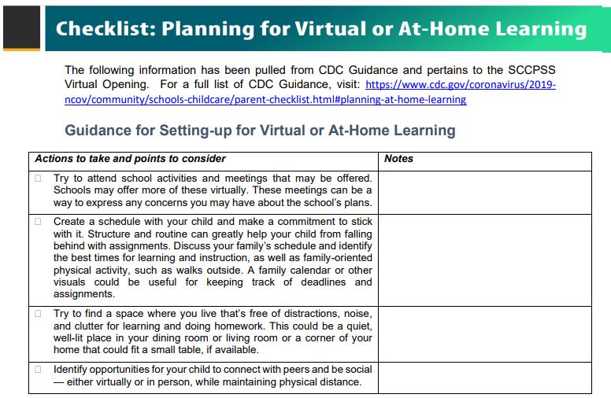
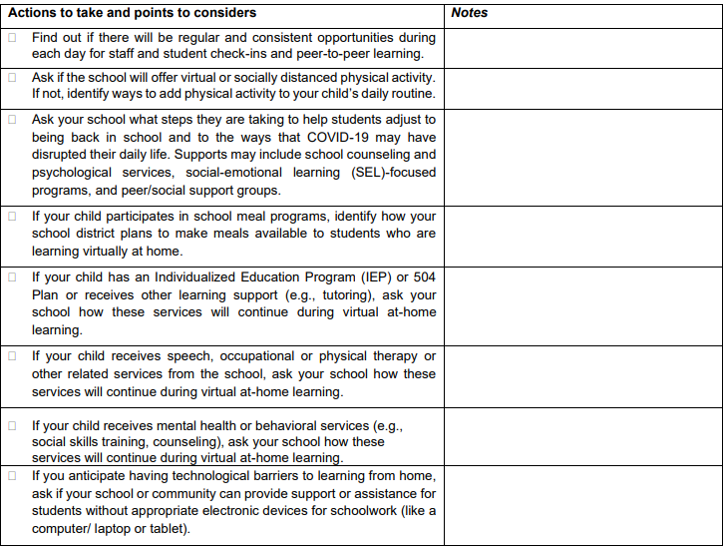
School Face to face part of the Handbook
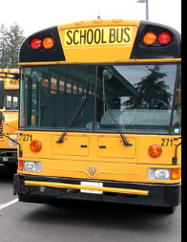Transportation (face to face only)
All transportation changes must be sent to school in writing. I cannot change your child’s transportation home just because they tell me that mom or dad told them it was different. If a change is needed to be made during the school day, please come to the school, or email me in writing. If your child is a walker and you do not want them to walk in the rain, please specify on the inclement weather sheet if they will be a car rider when it rains.

Lunch/ Breakfast Money (face to face)
Please send your child’s lunch money in a plastic bag or a pencil bag (it lasts longer) with their name on it. They will be responsible for their own lunch money. They can put it in my lunch bucket when they get in the classroom. Please send all lunch forms straight to the cafeteria. You can place money on your child’s account at Myschoolbucks.com

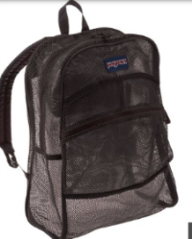Book Bag and Personal Belongings (face to face only)
Please make sure that you put your child’s name on their backpack, clothes, jackets, etc. Please get in the habit of checking your child’s book bag nightly. Please do not label crayons, pencils, glue sticks, etc. Class supplies will not be individual and will stay in the classroom. Please tell your child when he or she has something to turn in to me, such as a note or money. It is your child’s responsibility to unpack their book bag once they arrive at school. Please make sure that your child brings their book bag to school every day since I will be sending home their folder each day.
Please don’t allow your child to bring toys to school. If they are caught with them, they will be collected and returned when you come to get them.
Please send a change of clothes in a ziplock bag (name on it). I will keep this in case of an accident.
Illness, Absences and Tardies (face to face only)
It is very important for your child to be at school every day and on time. Students can enter the building at 8:55 for breakfast. Your child is expected to be in the classroom by 9:15 to begin their morning work. If he/she arrives at school after 9:15, he or she will receive a tardy pass. If you want your child to eat breakfast at school they need to be here by 8:55.
Afternoon Pick Up:
Buses will pick up at the back of the school beginning at 4:10. Walkers will be released first. Car riders must be picked up in a car at the front of the school beginning at 3:45.
If your child is sick, please keep them home so that the whole class does not get sick. Please notify me if your child has a contagious disease so I can inform other parents. When your child returns to school, please send in an excuse or your child will have unexcused absences. You must have that excuse on the day your child returns to school.
Absence policy:
- Only 5 handwritten notes may be accepted for the school year
- All other notes must be doctored excuses
- All excuses must be turned in within three days of your child returning to school or the day or days will be counted as unexcused absences
- After 5 unexcused absences your child is truant
- A child can be retained if they are absent 7 days in a semester or 15 days in a school year (this includes both unexcused and excused)

Please do not send any medicines for me to give your child. I can’t give any medicines, all medicines have to go through the school nurse.

Everything I send home will go in your child’s homework folder. In this folder will be a homework packet, assignment sheet, and a newsletter. Please discard items on the “Keep” side. Please send any letters, money, important documents, etc. in the “Return” side of the folder.
Homework is an option. However, it is very important because it is a review of daily work. Please help your child with their homework as needed, but let them attempt to do their own homework.
Please refer to the homework explanation sheet for more details.
Your child will be able to check out books from our class library. It is his or her responsibility to check out a book during the morning work time. Responsible students and students that finish their work can get library books from the school library.
I send home graded papers on Monday. Please sign grades 70 or below grades, sign on the front sheet, and then send the folder back. You may keep the papers that are not graded, please send the graded papers back. I will return some papers to you on the return side of the folder. Please ask if you have questions about graded papers, or need to schedule. If students' graded papers, there will be “checked by and initials”. Some papers are only checked for understanding, it will just have a check mark. Everything we do in the classroom is checked or graded.

(face to face maybe)

All parents are welcome in our classroom. If you would like to visit, please let me in advance, so I can be sure we will be in the classroom during the scheduled time. Anytime you enter the building, to come to our classroom, you must first sign in at the office and get a visitor pass. Please do not come unannounced for a conference, please schedule one by contacting me. Anytime that you are in our classroom, I ask that you please not be on your cell phone because it does disrupt instructional time.

