Rules
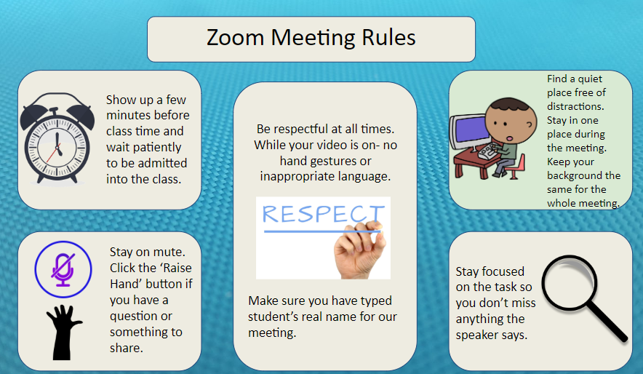
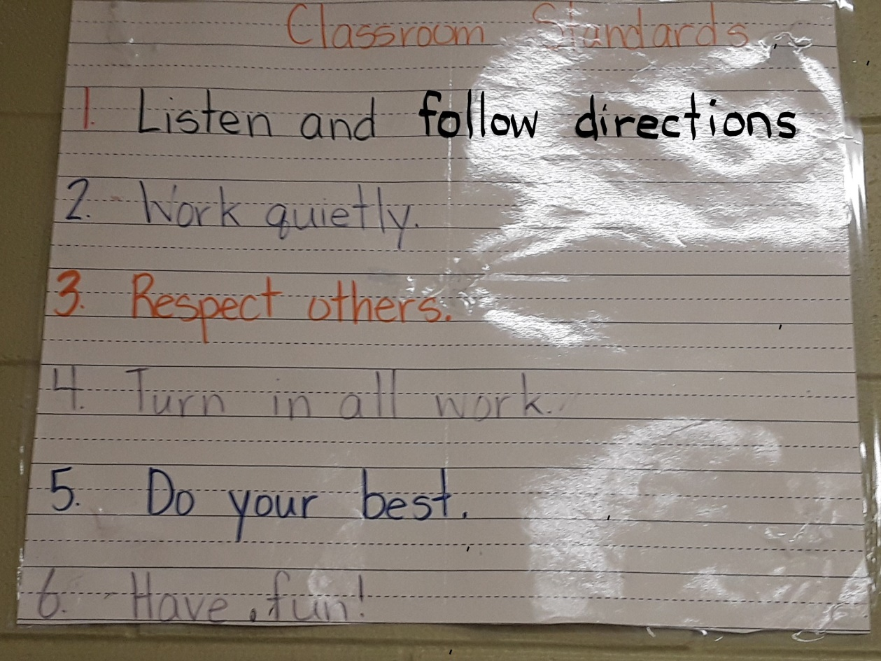

S.O.A.R. Virtual Learning Matrix
S  Self Control | Follow Instructions  Wait for your turn to speak  Use the Raise Your Hand button to speak  Stay focused on your work, assignments and teacher lessons  Use the chat feature responsibly
O  On Task | Log on in time  Be actively engaged and participate  Have your materials together and ready  Set daily goals  Make yourself visible
A  Awesome Attitude | Complete tasks on time  Be prepared  Be positive about learning  Share what you learn
R  Respectful | Mute your microphone while others are speaking  Respect others while they are speaking  Help others during group assignments  Resolve conflicts peacefully

Please, no toys or things that will be distractions for your child.
Students need to be presentable like they would be in school.
Students need to have all materials in their learning area and ready to learn.

Virtual Discipline Procedures:
I will communicate through Class Tag if your child is not following the rules. I will talk to your child after class about the behavior. If the behavior continues to happen, then we will need to schedule a conference. Your child is here to learn so I take misbehaving very seriously because it takes away from others learning. I need your help with this, so please address your child about his or her behavior.
I will use a street light for virtual learning. Your child starts on green light and if I have to speak to them during teaching 3 times; then on that 3rd time I will switch the color. Your child will have many opportunities to get back to green. I will cross out the strikes every time the student is doing great and when the strikes are gone, then the child is back on the green light. At the end of the day, I will only message you on Class Tag, if your child is on yellow or red. At the end of the week if your child has been on green all week they will get to participate in a fun activity on Friday.
If your child is on yellow, then he or she broke a couple of rules and we discussed the behavior. If your child is on “sad” (red) face, I had to call his or her name several times. When your child is on yellow or red, they will get a piece of paper and draw a picture or write about what he or she was doing and how he or she can do better. We will discuss the behavior after class.
If I have a sub and your child misbehaves, they will start on yellow the next day.

Outstanding (Green)  Participate in fun activity Friday | Ok (Yellow)  -Think about it (Refocus)  -Discuss behavior  - Parent note | Sad (Red)  -Discuss behavior  -Think about it (Refocus)  -Parent call

Discipline steps:
1. Verbal Warning
2. Parent Contact
3. Parent Conference
4. Administration is involved
Thank you for reviewing the Discipline Procedures. Please fill out the google form stating that you have read them.
https://docs.google.com/forms/d/e/1FAIpQLSc66bhQYBFlkS7xInoR8hSaOS5O3Sp5JShHWbkd7CVRkx-y4A/viewform?usp=sf_link

